|  |  |  |  |  |  |
| --- | --- | --- | --- | --- | --- |
| Date | 30-Nov-22 | | | Tester Name | Mayuri Patel |
| Environment | Penfax - Test | | | Login used |  |
| Operating System | Select OS | Version: | Update: | | |
| Software Used | Select Software | Version: | Update: | | |
| Select Software | Version: | Update: | | |
| Release version | 22.4.1 | | | | |
| Title |  | | | | |
| Test Type | Regression | | | | |
| Test Scenario | Process a lump sum payment with regular payments | | | | |
|  |  | | | | |
| Expected Results |  | | | | |
| Pass/Fail | Pass | | | JIRA# | N/A |

Describe your steps with screenshots:

Search for a member that have current Scheduled withdrawal Instruction under Account Instruction Under Investment

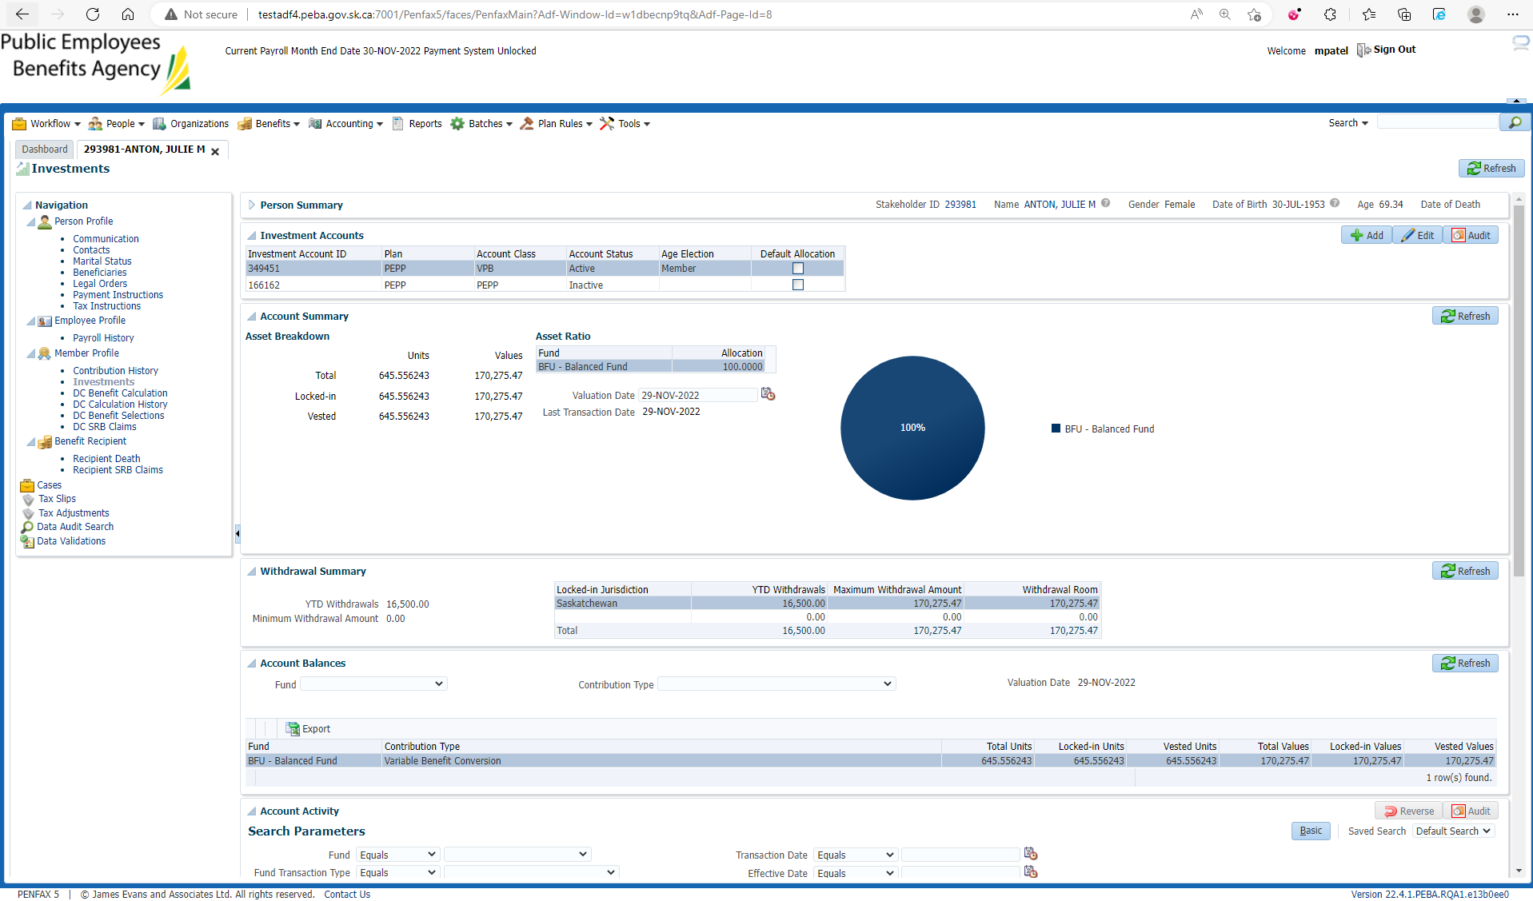

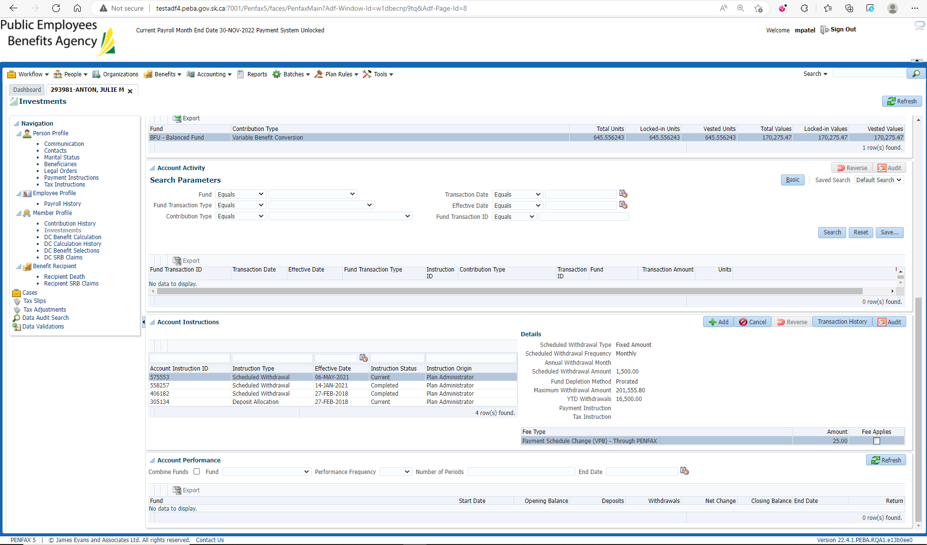

For making a lump sum payment

Go to DC Benefit Selection and next

Add Allocation by dollar amount and Save

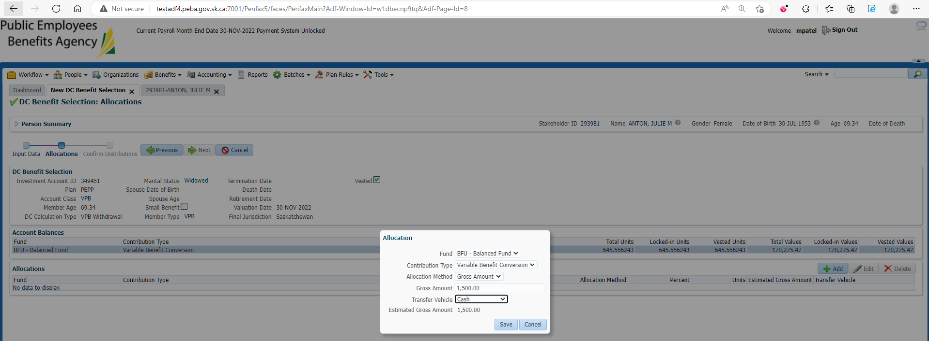

Submit for Approval and Approve it

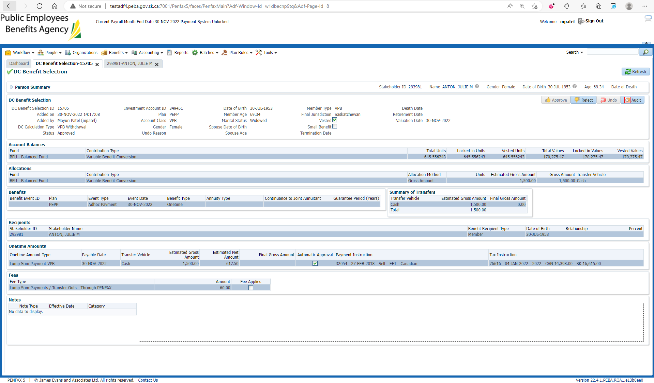

After Overnight PIT Batch

Open that member profile

Go to Benefit Recipient🡪 Onetime Amount

Yesterday’s payment has been processed

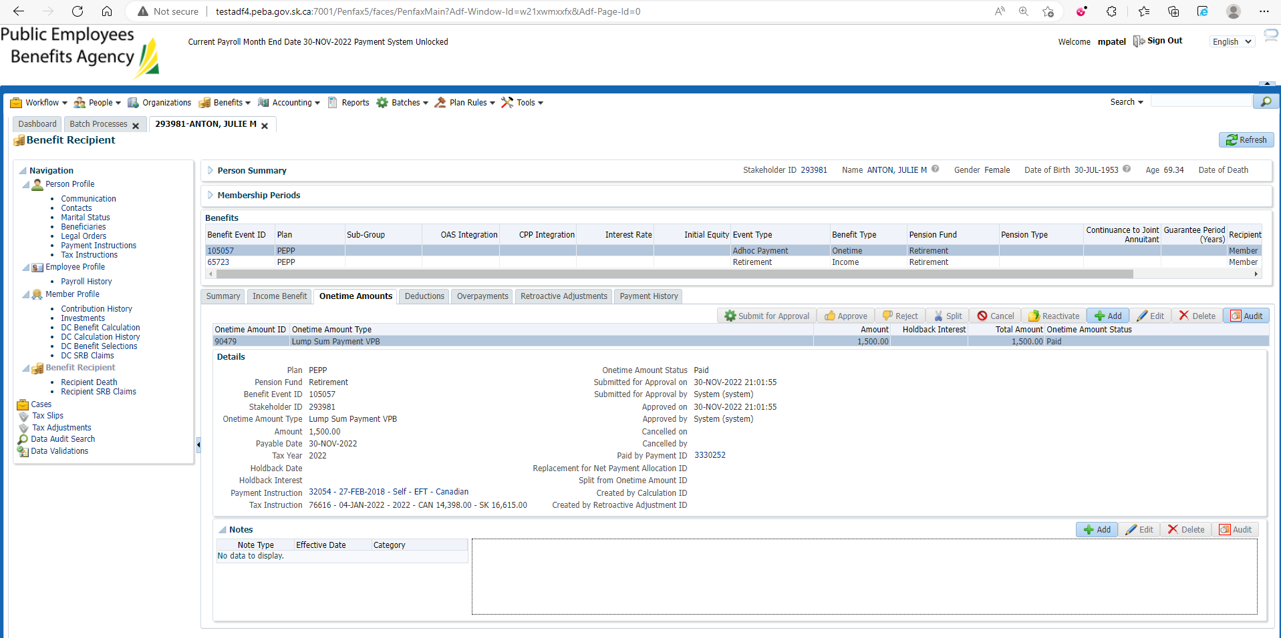

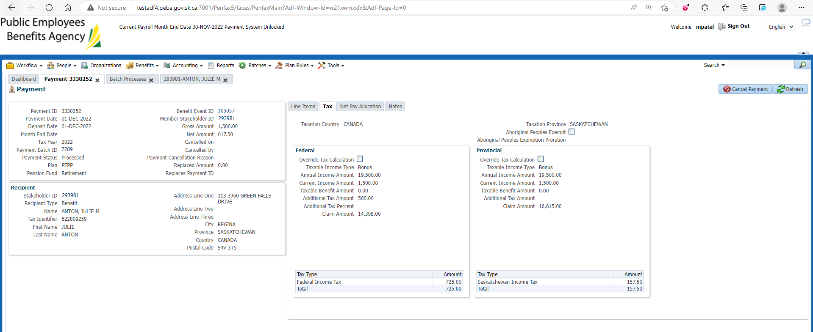

Go to Communications under Person Profile

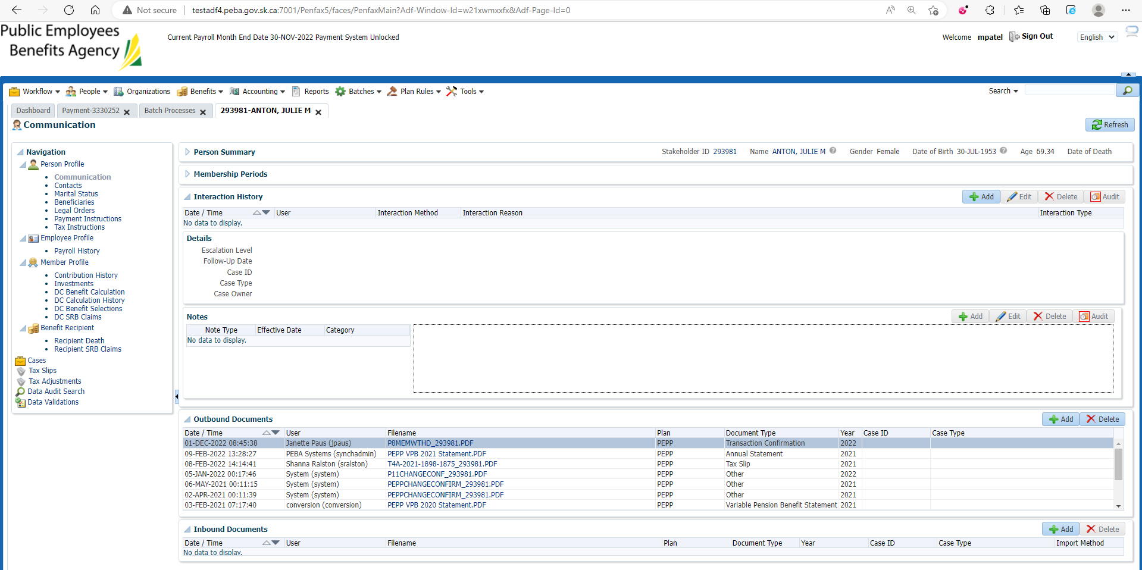

Download & Open PEPP Member withdrawal Letter

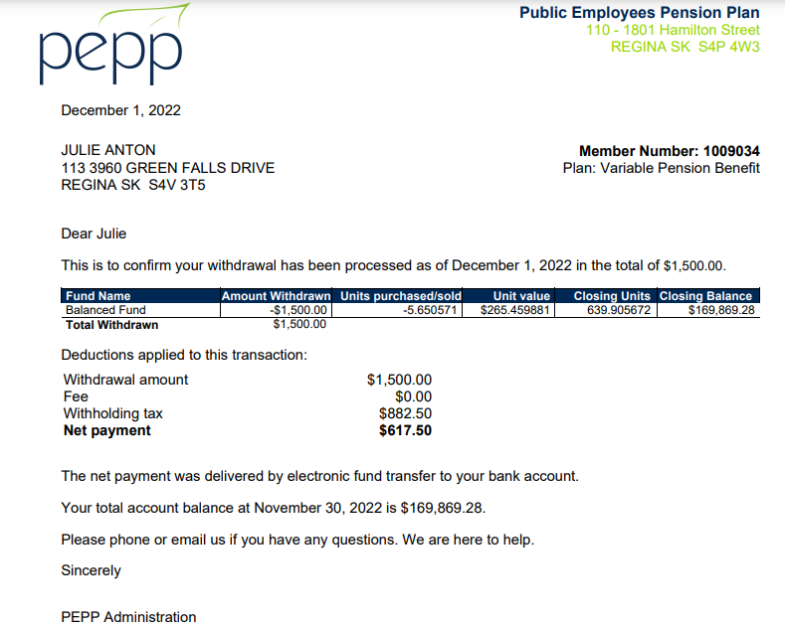

Check the Valuation Report. Go to Batches -> Batch Processes. Search with “PEPP Valuation Report” as Batch Process Type and open the very first record in the list (batch processed a day before).

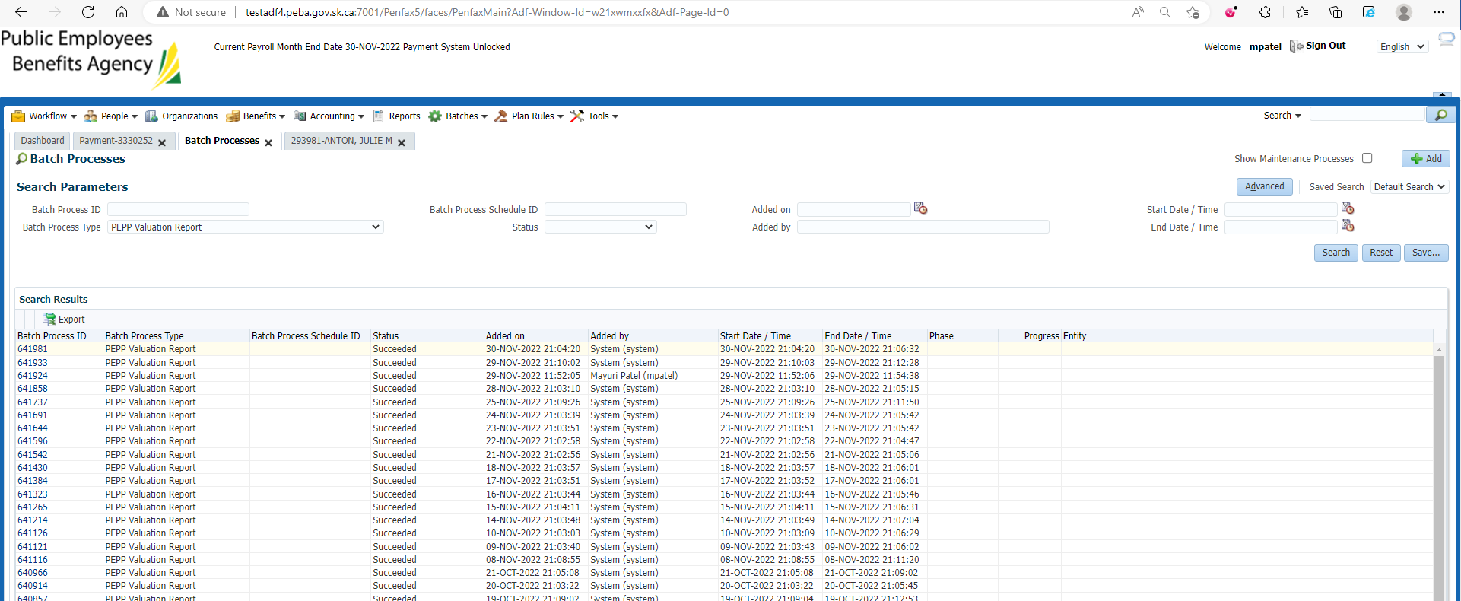

Go to Files tab and open VPB valuation excel

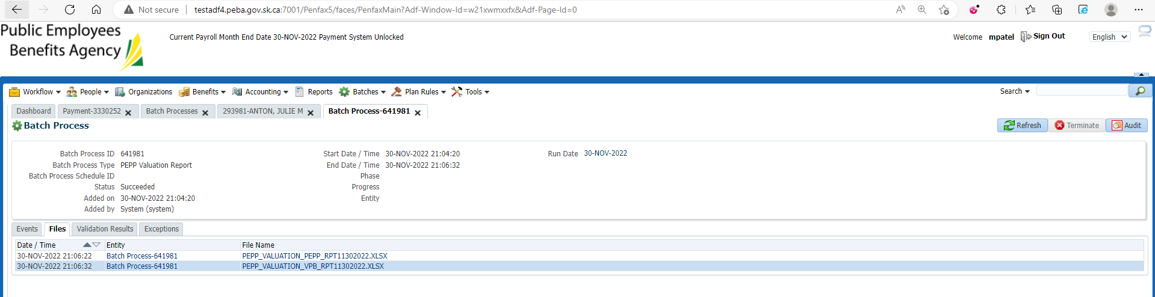

Section Seven

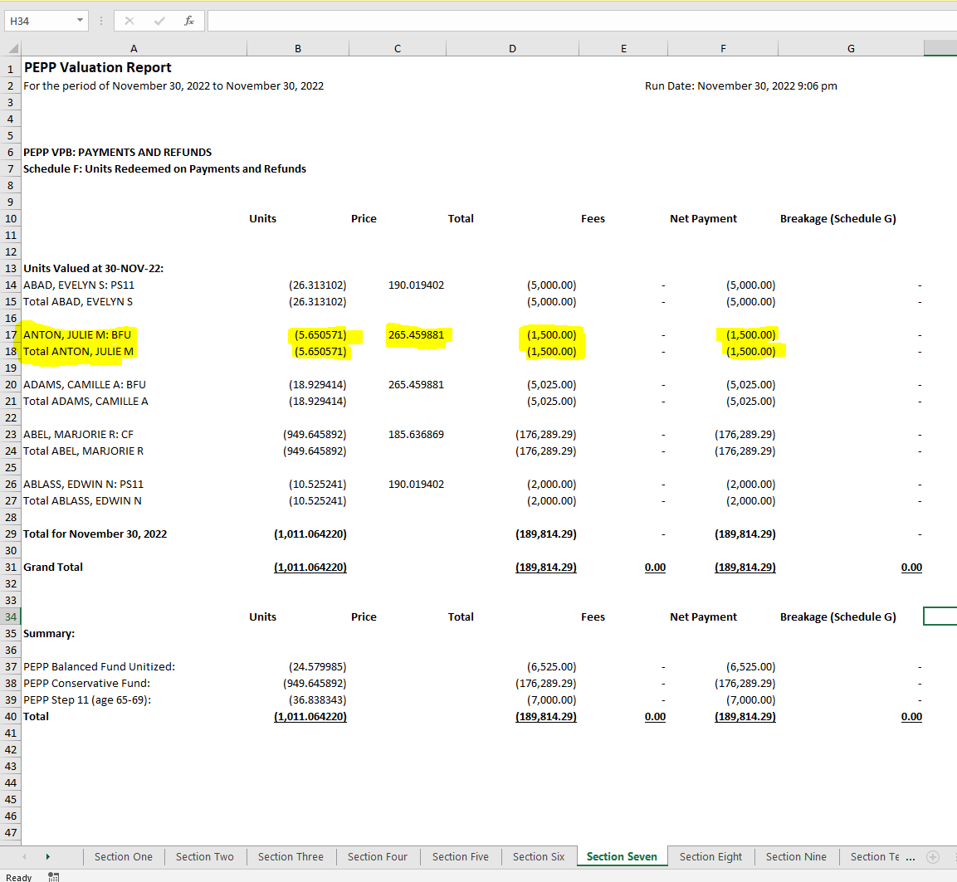

Same steps when followed through penweb

